Available online at [www.sciencedirect.com](http://www.sciencedirect.com/)



AASRI Procedia 3 (2012) 636 – 641

2012 AASRI Conference on Modelling, Identification and Control

Power Supply of Vertical Stability Coil in EAST

Haihong Huanga, Ruobing Xua, Ge Gaob

*aHefei University of Technology, Hefei 230009, China;*

*bInstitute of Plasma Physics, Chinese Academy of Sciences, Hefei 230031, China*

Abstract

Power supply of vertical stability coil in EAST(Experimental Advanced Superconducting Tokamak) traces given signal from PCS(Plasma Control System), supplies excitation current of active feedback coils in vacuum chamber, then magnetic field will be product to restrain plasma vertical displacement in large elongate model. It is a kind of single phase inverter power supply with large capacity, which consists of HV switches, AC/DC converters, 24 3-level half bridges with diodes neutral point clamping IGBT modules in parallel, it can output large current with fast response ability. To decrease switching loss of IGBT, the technique of carrier wave phase-shift PWM is applied in IGBT modules, which can raise converter equal switch-frequency and improve output wave quality. The result of simulation and experiments show that scheme and control strategy are effective. The power supply has been under operation since 2006 in the EAST Tokamak.

© 2012 The Authors. Published by Elsevier B.V. Open access under [CC BY-NC-ND license.](http://creativecommons.org/licenses/by-nc-nd/3.0/)

© 2012 The Authors. Published by Elsevier B.V.

Selection and/or peer review under responsibility of American Applied Science Research Institute

Selection and/or peer review under responsibility of American Applied Science Research Institute

*Keywords*: EAST; Plasma; Vertical unstable displacement; Fast control power supply

1. Introduction

The toroidal magnetic constraint Tokamak device is most hopeful to build commercial nuclear fusion power reactor. But Tokamak is a kind of low-*β* device. *β* is the ratio of plasma pressure and magnetic energy density, which represents the ability of magnetic field to constrain the plasma. The value of *β* is general 1%10%. Considering the economic benefit, the average value of *β* should be about 10% to build a commercial reactor. Therefore, how to increase the value of *β* has become a very important subject among the international study of nuclear fusion. The most popular method to increase value of *β* is elongating plasma cross-section to form divertor configuration, [1] but corresponding vertical displacement instability of elongated plasma must be overcome. Some kind of disturbance will cause vertical displacement of the elongated plasma. As a result, plasma will move at the vertical direction.

2212-6716 © 2012 The Authors. Published by Elsevier B.V. Open access under [CC BY-NC-ND license.](http://creativecommons.org/licenses/by-nc-nd/3.0/) Selection and/or peer review under responsibility of American Applied Science Research Institute doi:10.1016/j.aasri.2012.11.101

Plasma will dash to the wall of vacuum vessel and disrupt without control. It causes failure of discharge, the high heat load stress and a lot of runaway electrons caused by the disruption may be serious or even destructive. [2] So the feedback control system must be built to control vertical displacement of plasma.

Passive feedback and active feedback are two methods to restrain plasma vertical displacement. Passive feedback is a kind of fast response on millisecond level. Once plasma moves at vertical direction, conductor around the plasma (such as the metal wall of vacuum vessel) will induce eddy current, which will produce magnetic field. The radial component of the magnetic field *B*R interacting with the plasma current produces Lorentz force at opposite direction to plasma, so that the vertical displacement is suppressed. The passive feedback to plasma vertical displacement in EAST is formed by double layer stainless steel vacuum vessel and two pairs of passive conductor plate. But passive feedback will be weakening after the conductor diffusion time because the eddy current will be dissipated by conductor resistance. Therefore, active feedback is needed for slow disturbance beyond the diffusion time scale. Method of active feedback is to detect plasma's vertical displacement and feed it back to the control power supply, then excitation current in the active feedback coils will be built, and magnetic field will be product to restrain the plasma's vertical displacement.

Power supply of vertical stability coil in EAST is a kind of single phase inverter power supply with large capacity, which traces given signal from plasma control system, supplies excitation current of active feedback coils in vacuum chamber, then magnetic field can be product to restrain plasma vertical displacement. The maximal output voltage is ±800V and maximal output current is ±5000A; Current responding time from -5000A to 5000A is less 5ms. To meet the demand of fast dynamic response, IGBT is used as power device in power supply. But large capacity IGBT can not work with high switching frequency, while the PWM control with low switching frequency will produce low frequency harmonics in output wave. Thus the technique of multi-inverters in parallel and phase-shift PWM is the best solution to this power supply.

1. Structure of Power Supply

Power supply of vertical stability coil is made of HV switches, transformer, AC/DC converters, filter and clamping circuits, DC/AC inverters, current-shared and protection circuits as shown in Fig.1. The transformer converts grid voltage 10kV to 700V. To improve quality of grid current, there are 12 groups of secondary winding with ±5°, ±15°, ±25° phase shift to primary winding. Two identical windings with AC/DC converters and filter circuits supplies DC power for 4 inverters. At last all 24 inverters are connected in parallel with current-shared inductor. [3]

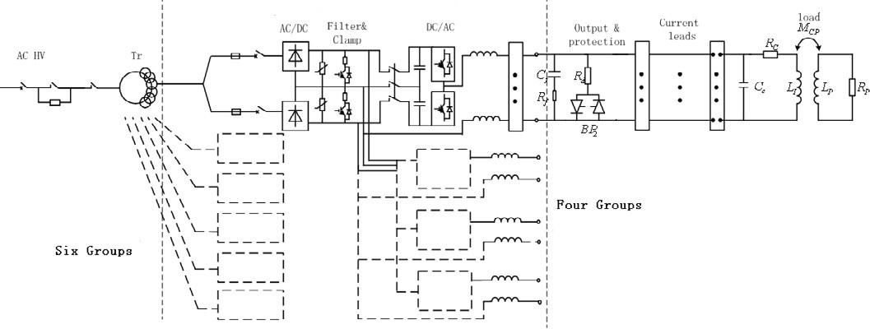

Fig.1.Structure of the power supply of Vertical Stability Coil of EAST

In the case of IGBT module over-current, the drive signal of IGBT modules will be blocked and the corresponding AC switch of transformer will be opened. And in case of load over-current, IGBT modules will be blocked and the thyristor at the terminal of output will be fired, thus the load current will pass this crowbar. In the case of short-circuit, the AC breaker and the fuse in series with the AC/DC converter will work to isolate the AC power. The over-voltage will be depressed by the filter and clamp circuit shown in Fig.1. The IGBT in parallel will be triggered if the voltage is above the limit.

The structure of three levels half bridge with diodes neutral point clamping is used in inverter unit in power supply, which is shown in Fig.2. It can reduce power device voltage stress, switching frequency of power device and harmonic of output wave.



+U

*Cd*

*Lx*

*Cd*

-U

Fig.2. Main circuit topology of inverter unit

It is well known that large power device can not work with high switching frequency because of switching loss, but the PWM control of low switching frequency will produce low frequency harmonics in output wave. The technique of Phase-shift PWM in multi-inverters paralleled can solve this problem, which adopts common modulation wave in a combined PWM system, and the stagger phase angle of triangle carrier in each inverter will be 2π/*n* if there is *n* inverters paralleled in the system. This technique can raise equivalent switch frequency in the system, and reduces low frequency harmonics, so output wave will be improved. The simulation result shows that the amplitude of the largest harmonic reduces to only 3.3% with 24 inverters connected in parallel with phase-shift PWM. [4]

1. Control and Monitoring

The system principle of Power supply of vertical stability coil in EAST is shown as Fig.3. PCS detects vertical displacement of plasma and sends command signal to power supply. Power supply makes output current to track input signal real time and amplifying it linearly. The range of input signal is -10 V to 10 V, correspondingly output current is -5000 A to 5000 A.

There are two kinds of controller in power supply. One is system controller that controls the coil current according to the demand of plasma control and performs protection. The output of this controller is divided by 24 to controller in each inverter unit based on current feedback.

The monitoring system is be built with industrial control configuration software to monitor the status of power supply including grid voltage, grid current, load voltage, load current, output voltage of each unit,

Output current

Output voltage

Carrier waves(12)

Module temperature(24)

Unit current(24)

Unit voltage(24)

Control signal of units

Grid current

Grid voltage

Distribution control

output current and temperature of each module. In case of fault, this system will record the time, fault type and the wave. Also, this system can do some emergent protection.

All the current and voltage of each module as well as the load current and voltage are acquired and saved for later analysis.

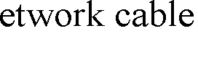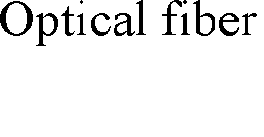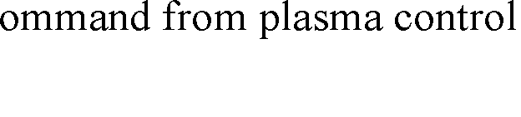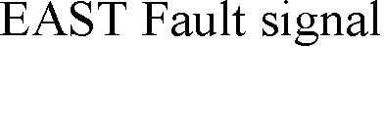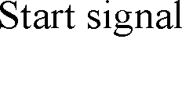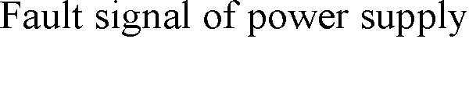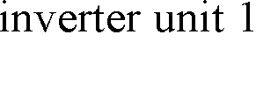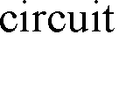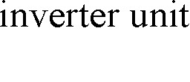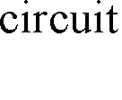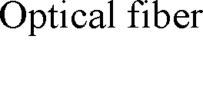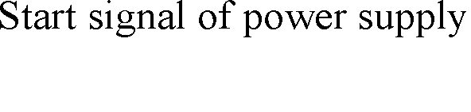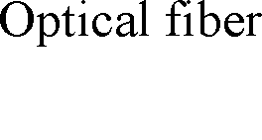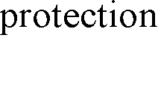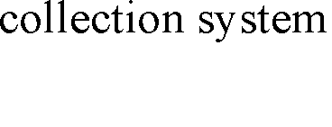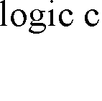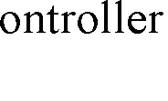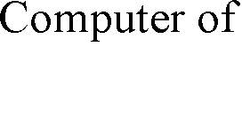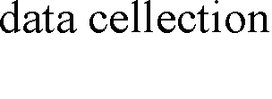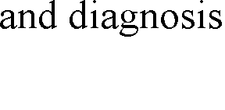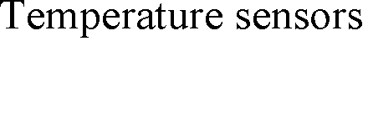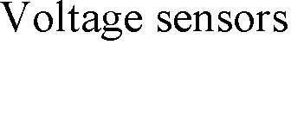





Fig.3. System principle of Power supply of vertical stability coil in EAST

1. Experimental result

To detect current-sharing coefficient, current RMS of each inverter unit is detected when input signal is sine wave with 100 Hz in frequency and 5V peak value as shown in table.1. The sum of current is 1830.3A, current-sharing coefficient is: [5]

*k*  *i*  0.97

*n* • *i*max

Table 1 Current of each inverter unit

|  |  |  |  |  |  |  |  |  |  |  |  |
| --- | --- | --- | --- | --- | --- | --- | --- | --- | --- | --- | --- |
| Unit | Current(A) | Unit | Current(A) | Unit | Current(A) | Unit | Current(A) | Unit | Current(A) | Unit | Current(A) |
| 1 | 76.5 | 5 | 73.5 | 9 | 76.0 | 13 | 76.5 | 17 | 74.4 | 21 | 76.2 |
| 2 | 76.4 | 6 | 78.0 | 10 | 76.0 | 14 | 78.5 | 18 | 75.3 | 22 | 77.2 |
| 3 | 77.2 | 7 | 76.0 | 11 | 76.1 | 15 | 73.0 | 19 | 79.0 | 23 | 74.9 |

|  |  |  |  |  |  |  |  |  |  |  |  |
| --- | --- | --- | --- | --- | --- | --- | --- | --- | --- | --- | --- |
| 4 | 76.6 | 8 | 75.2 | 12 | 75.8 | 16 | 75.5 | 20 | 78.2 | 24 | 77.6 |

Local computer of data collection detects the status of power supply in real time. Fig.4 is Current wave of 12 inverter unit, which shows that effect of current-sharing is well.

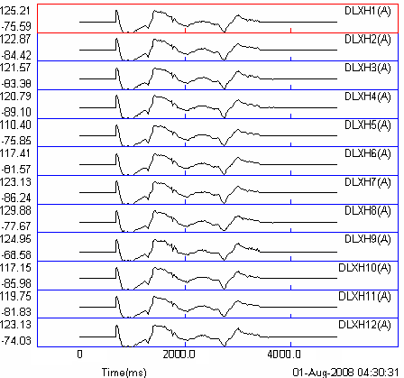

Fig.4.Current waves of 12 inverter unit detected by data collection computer

The function of Power supply of vertical stability coil in EAST is to track the given current signal in real time. Fig.5 shows an example in Tokamak operation. It shows waves of plasma vertical displacement signal, PCS command, and current on internal coil. The tracking performance of power supply is quite good and active feedback control can restrain the vertical displacement of the plasma well.

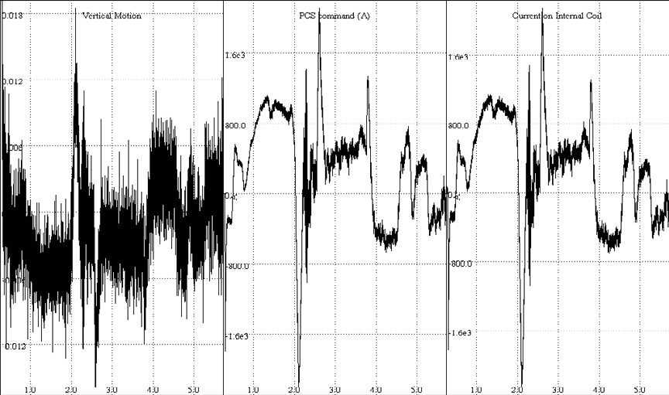

(a) Vertical Motion (b) command from plasma control (C) Current on Internal coil Fig.5.Experimental Result on EAST Tokamak

1. Conclusions

The method of paralleling inverters and control principle used in power supply of vertical stability coil in EAST are introduced. The main parameters such as ability of output current and responding time can meet requirement of EAST vertical stability coil power supply.

References

1. Bondeson A, Liu D.-H., Söldner F.X, Persson M., Baranov Yu.F, Huysmans G.T.A. MHD beta limits for advanced scenarios on JET. [J] Nuclear Fusion. 1999, 39(11): 1523-1533
2. LIU Cheng-yue, CHEN Mei-xia, WU Bin. Study on Vertical Displacement Instability on EAST Tokamak. [J] Nuclear Fusion and Plasma Physics, 2009, 29(4): 301-304
3. Haihong Huang, Haixin Wang, Ge Gao, Peng Fu. Application of Phase-shift PWM in EAST Fast Control Power Supply. [J] IEEE Transactions on Applied Superconductivity, 2010, 20(3), 1671-1675
4. HUANG Hai-hong, GAO Ge, FU Peng1, WANG Hai-xin, YAN Shi-chao. Application of Three-level Large Power Paralleling Inverter in EAST System. [J] Nuclear Fusion and Plasma Physics, 2008, 28(4): 358-361
5. HUANG Hai-hong, FU Peng, GAO Ge, WU Yi-bing. Paralleling Inverters Analysis of EAST Fast Control Power Supply. [J] Power Electronics, 2010, 44(3): 57-59